Name:- Davinder Verma

Group No:- 4

Student No:- 121802201

Prof Name:- Azer Karadag

Date:- 23/02/2021

Name Of The Work:- Inventory Test Answer Sheet

Question 1 (worth 15 marks)

Complete a class diagram to support what your team has learned so far about *Tiles R Us.* 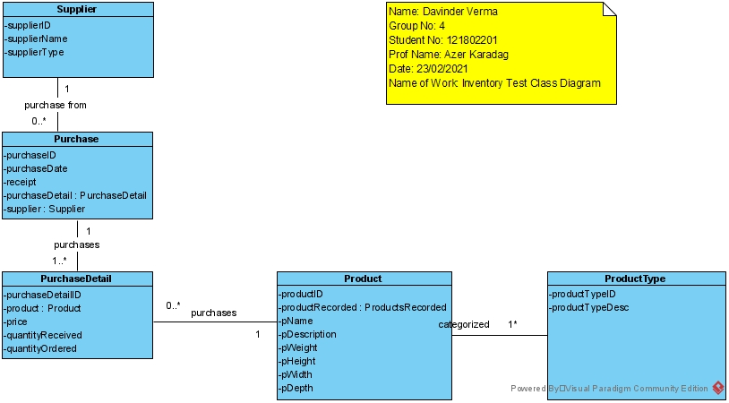

Question 2 (worth 20 marks)

Complete sequence diagrams to support the above scenarios.

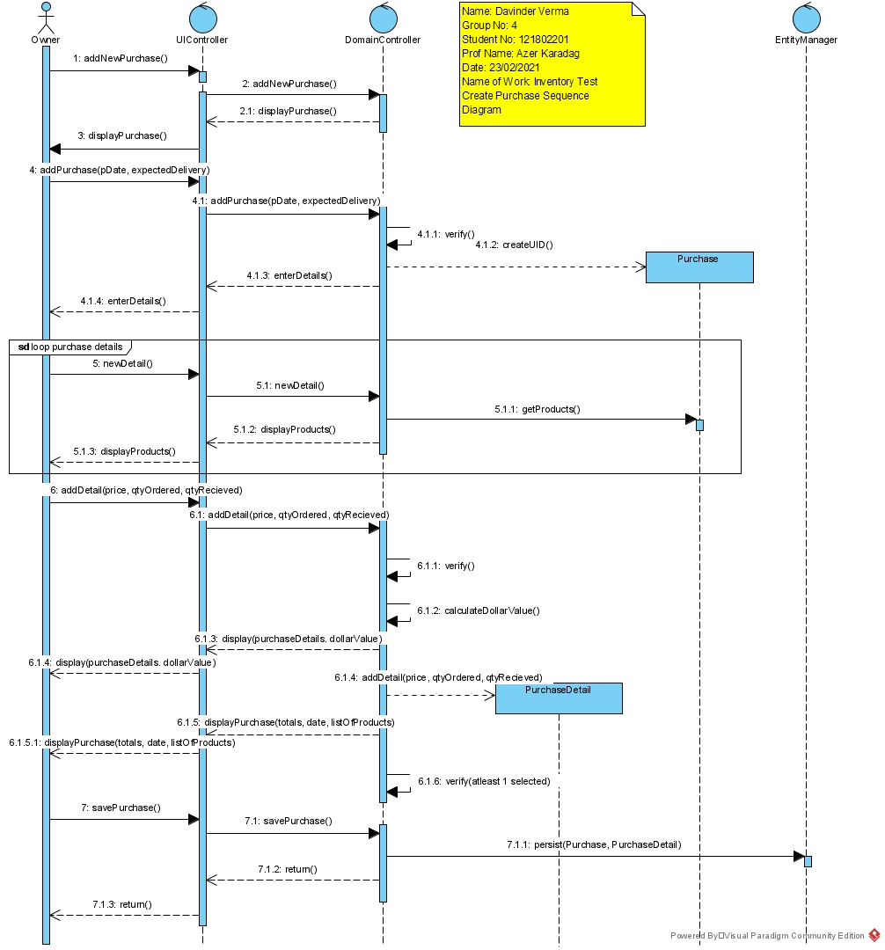

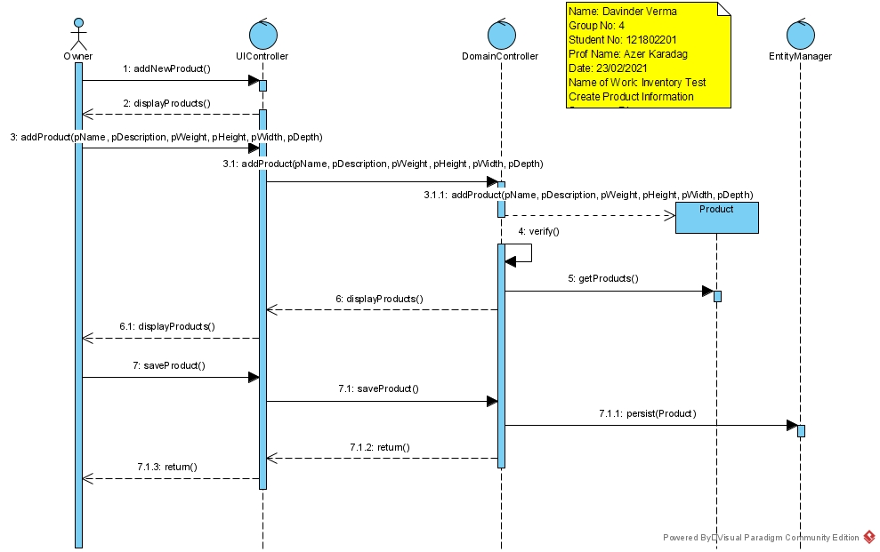

Question 3 (worth 2 marks)

Ally would like the system to suggest how much he should expect delivery to cost. To do that, she needs to know how much the purchase will weigh. How would you change your model to support this request?

*I will make a new description class. It will be named prodInventory and I will associate it with the products class that I already have. This way Ally will have the record of all the inventory which will include all the delivery costs and the purchase weight needed for any calculations.*

Question 4 (worth 2 marks)

What is WHMIS? Is this important to Ally?

*WHMIS stands for* ***W****orkplace* ***H****azardous* ***M****aterials* ***I****nformation* ***S****ystem. Its is Canada’s national hazard communication standard. Its main characteristics is to classify hazard, stick caution labels on containers that contains hazardous material, provision of safety data sheets and worker education and training programs. Its important for Ally as she runs a construction company. So the workers who work there should know all the hazardous material near them. It’s a law to educate the workers about their surroundings and all the risks related to the work.*

Question 5 (worth 2 marks)

Ally finds a sale on vinyl flooring and would like to buy six months’ worth of product. How would she use your model to figure out how many to buy?

*Ally can start with checking the inventory, if she has the vinyl flooring in stock or not and if yes then how much. With all these questions she can use our model and come up with a quantity that she needs to buy according to the inventory.*

# References

"Workplace Hazardous Materials Information System (WHMIS ...." <https://www.canada.ca/en/health-canada/services/environmental-workplace-health/occupational-health-safety/workplace-hazardous-materials-information-system.html>.